CSE 691 – Homework 1 – Report

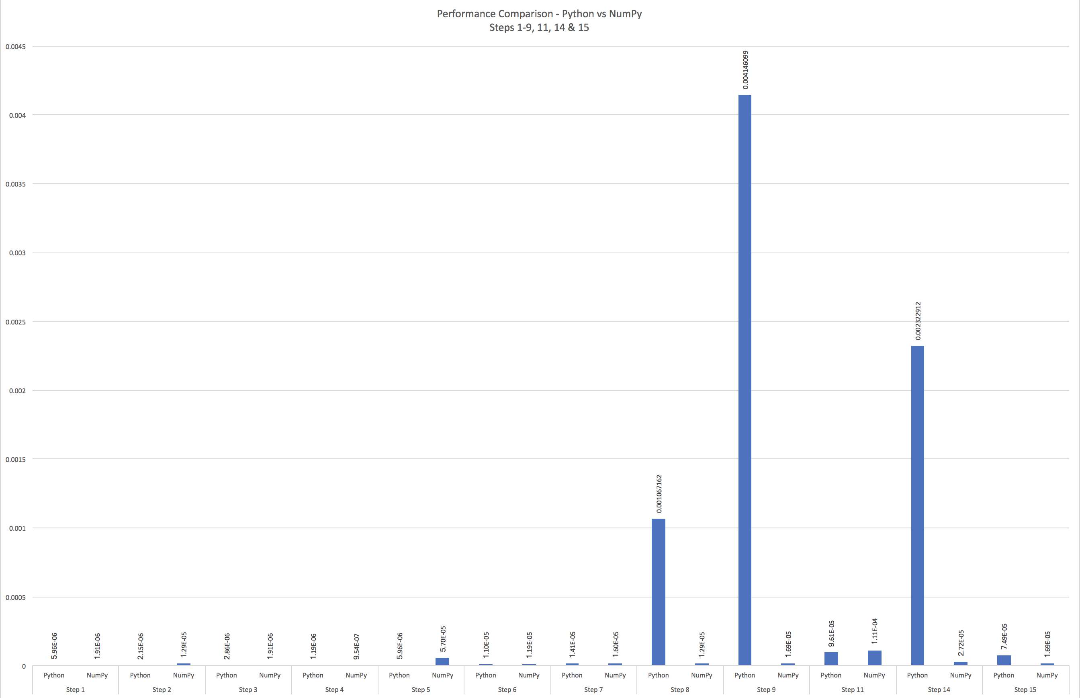

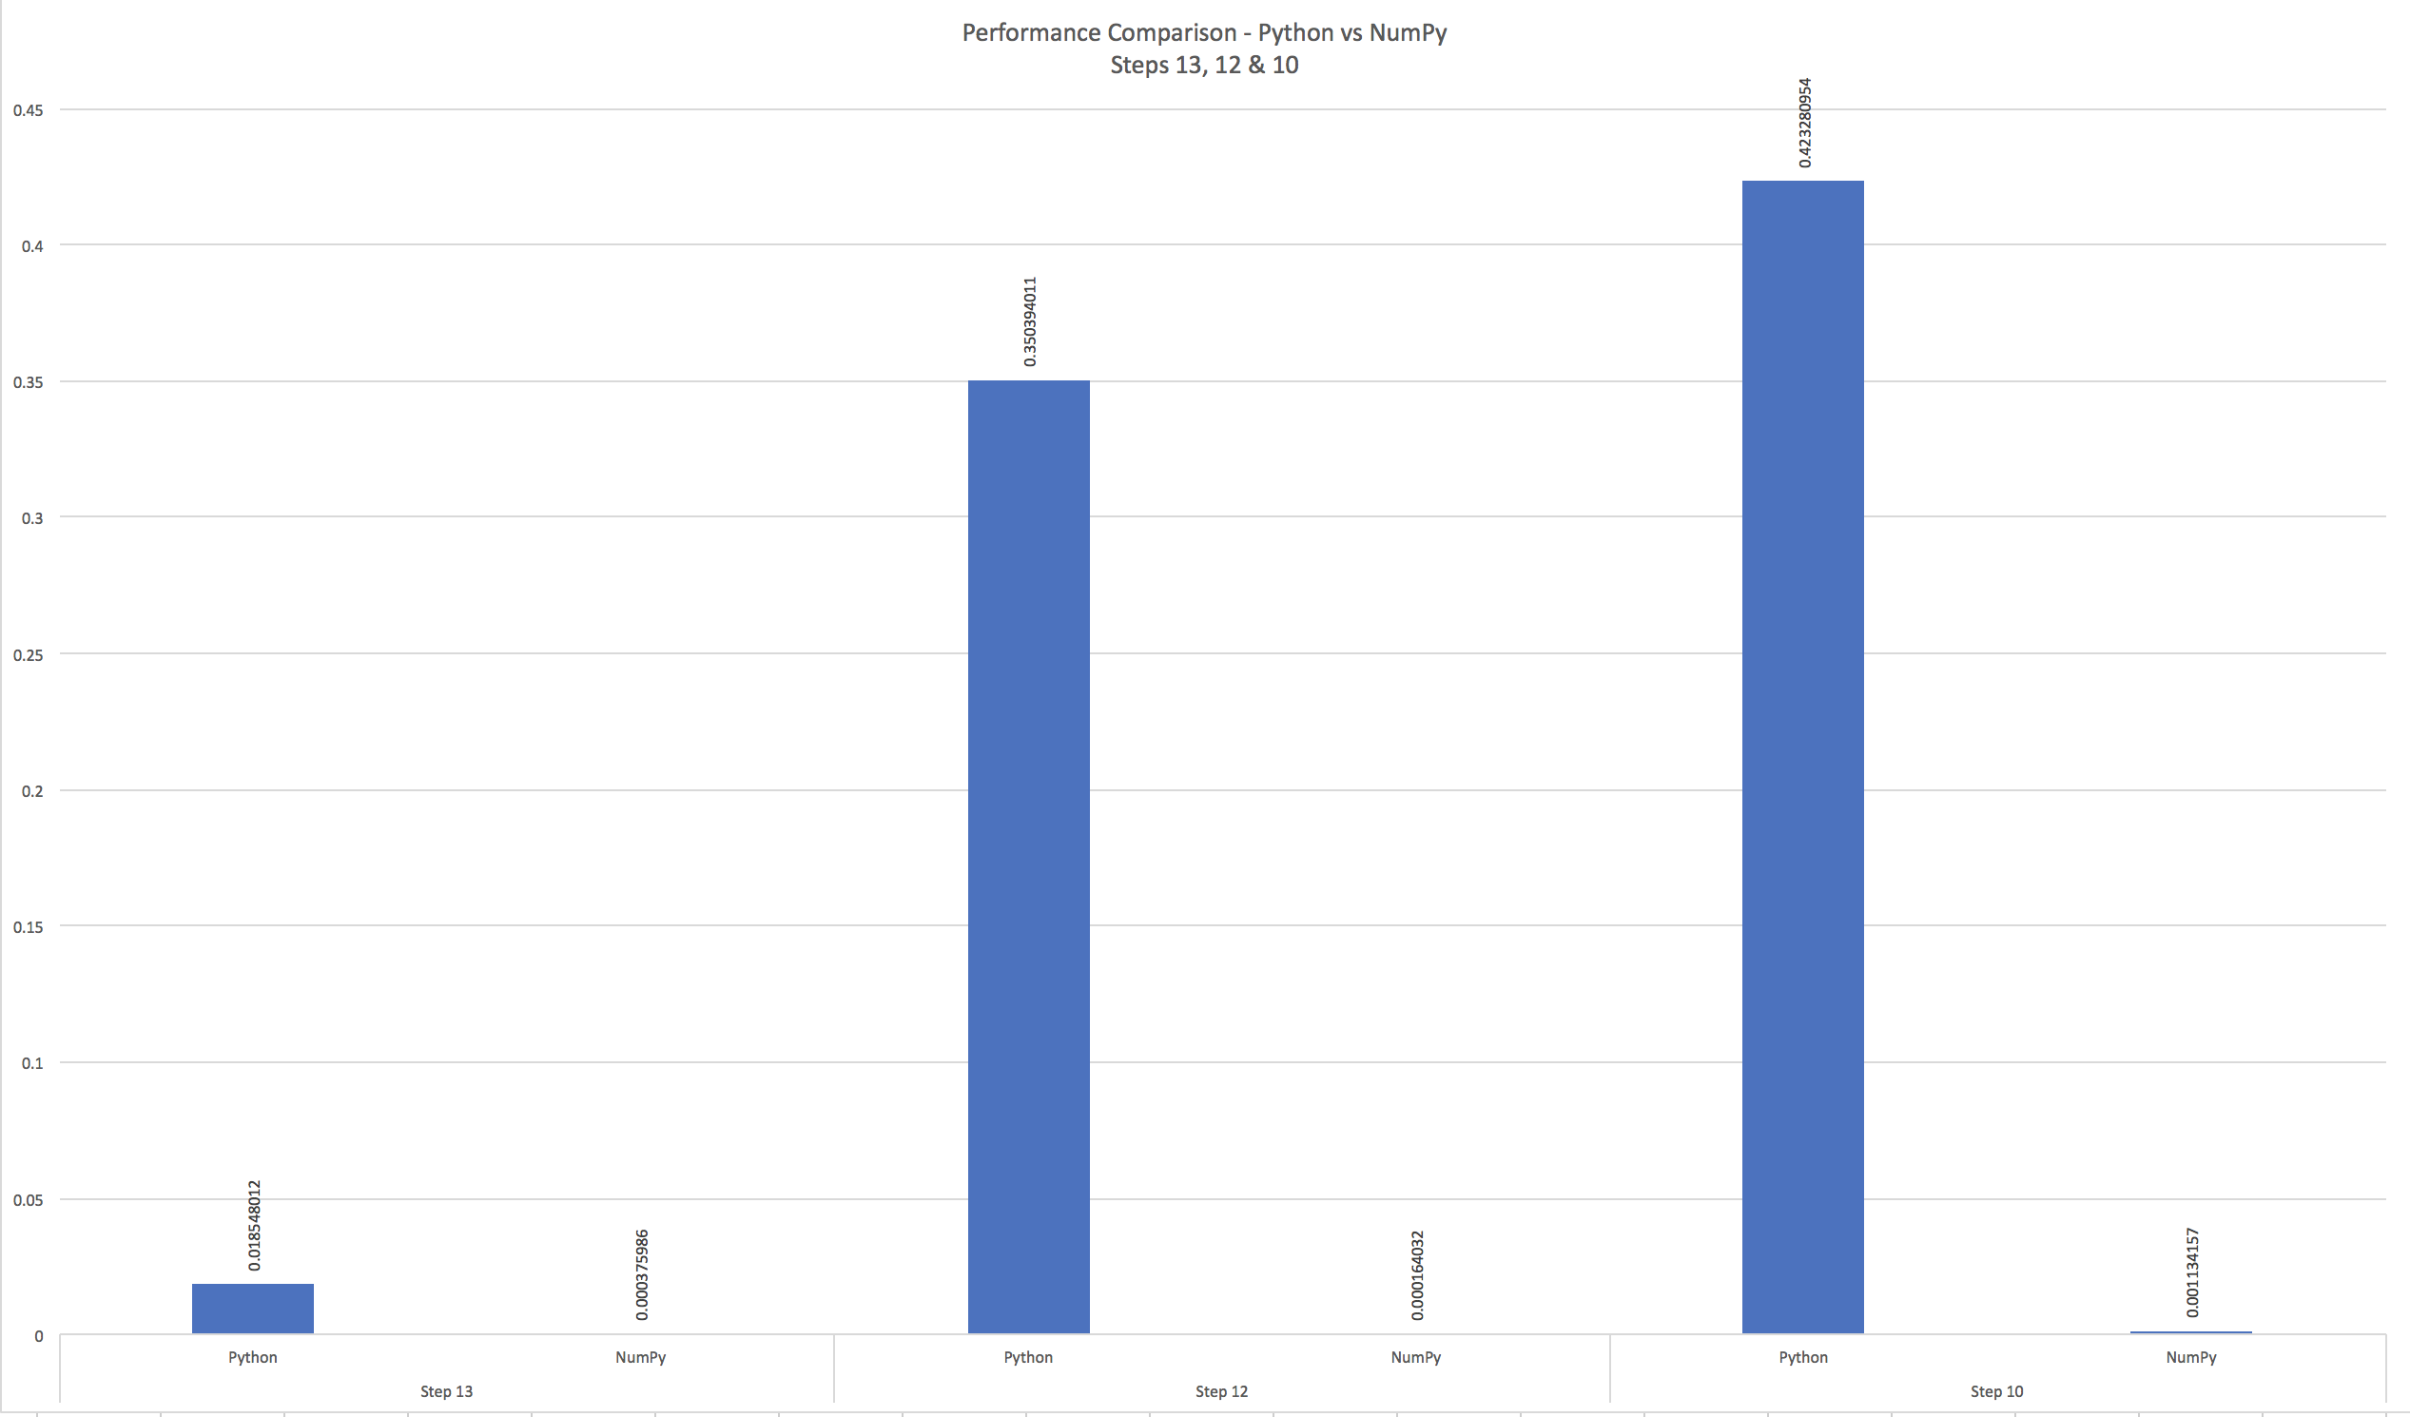

|  |  |  |  |
| --- | --- | --- | --- |
| Steps | Python/NumPy | Execution time in secs | Faster is |
| Step 1 | Python | 5.96E-06 | NumPy |
| NumPy | 1.91E-06 |
| Step 2 | Python | 2.15E-06 | Python |
| NumPy | 1.29E-05 |
| Step 3 | Python | 2.86E-06 | NumPy |
| NumPy | 1.91E-06 |
| Step 4 | Python | 1.19E-06 | NumPy |
| NumPy | 9.54E-07 |
| Step 5 | Python | 5.96E-06 | Python |
| NumPy | 5.70E-05 |
| Step 6 | Python | 1.10E-05 | Python |
| NumPy | 1.19E-05 |
| Step 7 | Python | 1.41E-05 | Python |
| NumPy | 1.60E-05 |
| Step 8 | Python | 0.001067162 | NumPy |
| NumPy | 1.29E-05 |
| Step 9 | Python | 0.004146099 | NumPy |
| NumPy | 1.69E-05 |
| Step 11 | Python | 9.61E-05 | Python |
| NumPy | 1.11E-04 |
| Step 14 | Python | 0.002322912 | NumPy |
| NumPy | 2.72E-05 |
| Step 15 | Python | 7.49E-05 | NumPy |
| NumPy | 1.69E-05 |
| Step 13 | Python | 0.018548012 | NumPy |
| NumPy | 0.000375986 |
| Step 12 | Python | 0.350394011 | NumPy |
| NumPy | 0.000164032 |
| Step 10 | Python | 0.423280954 | NumPy |
| NumPy | 0.001134157 |

As we can see from the above graph & table, execution time for 10 steps is higher in python & for 5 steps is higher in numpy. So, in most cases numpy is faster than native python as its highly optimized for scientific calculations. Because its highly optimized for calculations, some very small & easy steps are very slightly slower in numpy as data structures would be differently represented internally in numpy.

Since numpy faster in most steps & significantly faster in some steps, its highly desirable to use it. Also, its easy to use as its syntax is similar to math-like notations& thus making it much easier to code using numpy and this greatly overshadows the small area where it slightly underperforms.